**Tableau 2019.4 New Features**

* Webhooks Support
* Sandbox Extensions
* Explain Data Improvements
* User visibility site control
* Level AA Accessibility compatibility
* Ask Data Improvements
* SAP HANA Connector Improvements
* LinkedIn Sales Navigator connector
* Data Quality Warnings for tableau mobile
* Activity feed Improvements
* Table improvements
* Auto recover Web authoring sessions
* Creating Extracts in the Web browser
* Custom welcome banner for tableau server
* Edit tooltips in the browser
* Map improvements in the browser
* View Recommendations
* Go to where a sheet is used
* Qubole Connector
* Kyvos Connector
* Alibaba Connectors
* Cloud file connectors for Table
* App lock using biometrics

1. **Webhooks Support**:

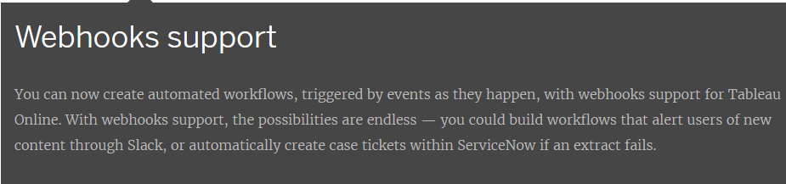

1. **Sandbox Extensions:**

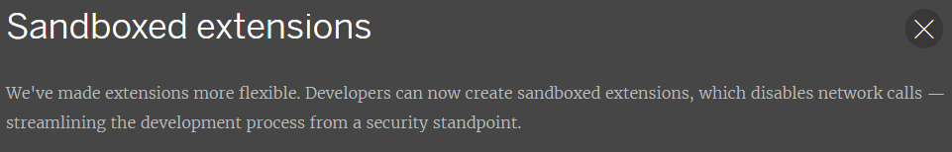

1. **Explain Data Improvements:**

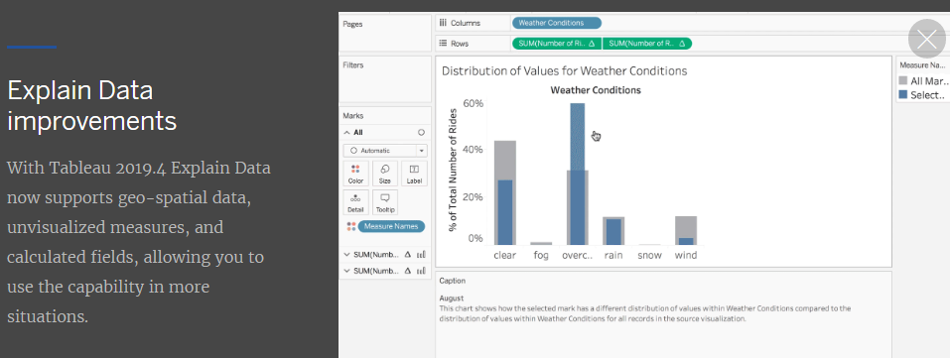

1. **User visibility site control:**

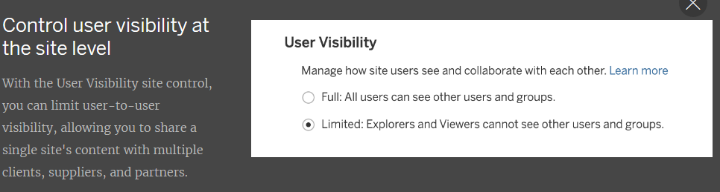

1. **Level AA accessibility compatibility:**

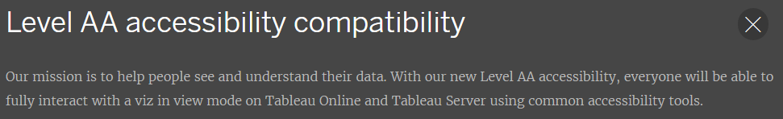

1. **Ask Data improvements:**

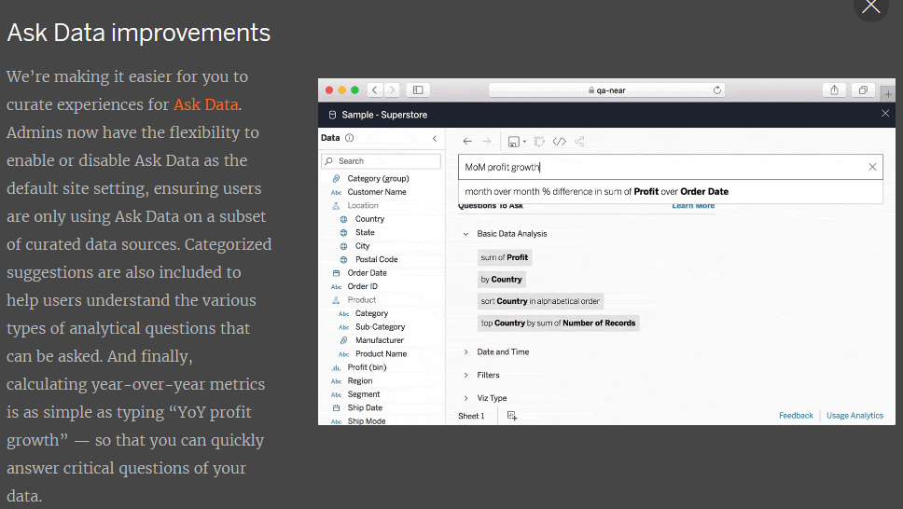

1. **SAP HANA connector improvements:**

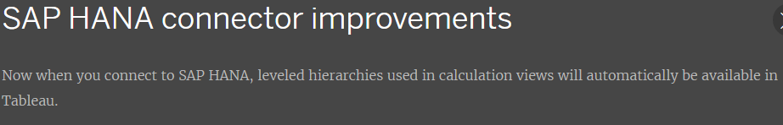

1. **LinkedIn Sales Navigator connector:**

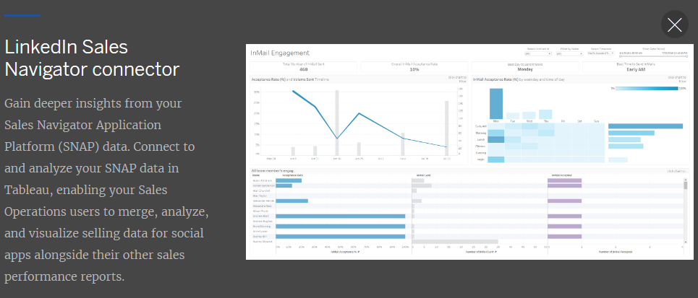

1. **Data quality warnings for Tableau Mobile:**

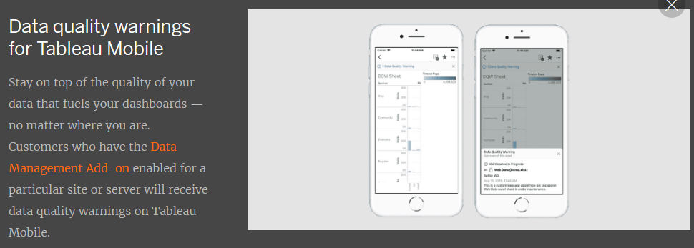

1. **Activity feed improvements:**

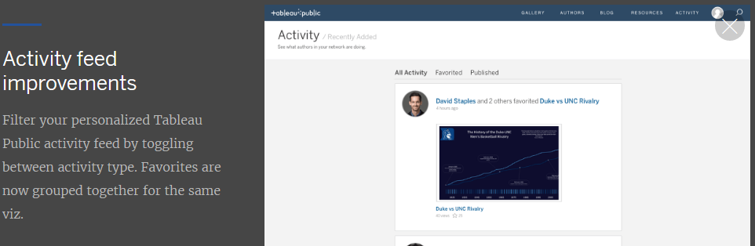

1. **Table Improvements:**

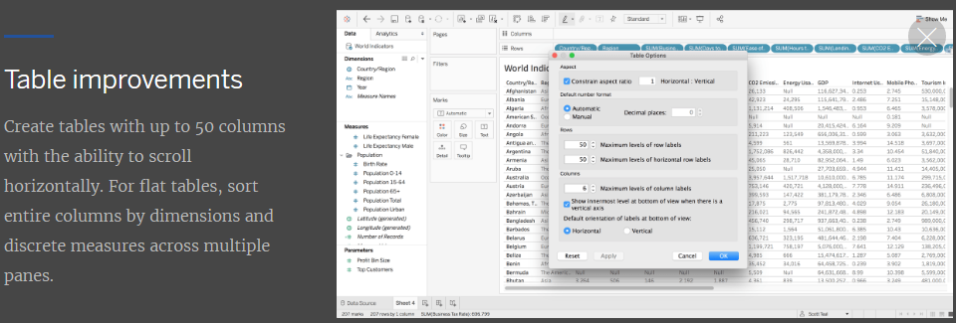

1. **Auto recover web authoring sessions:**

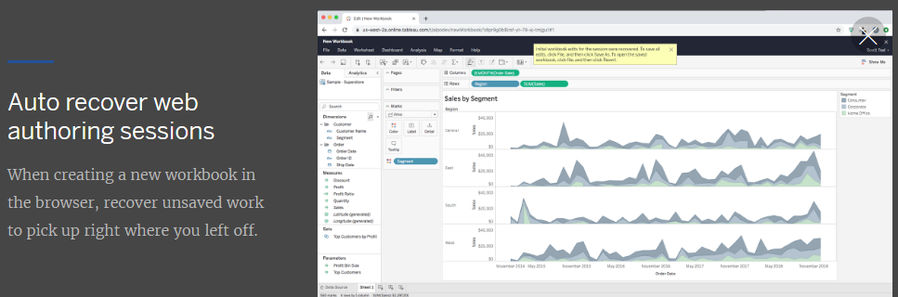

1. **Create extracts in the browser:**

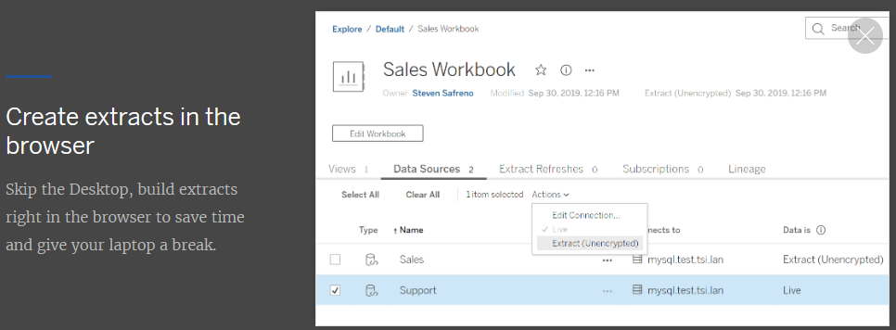

1. **Custom welcome banner for Tableau Server:**

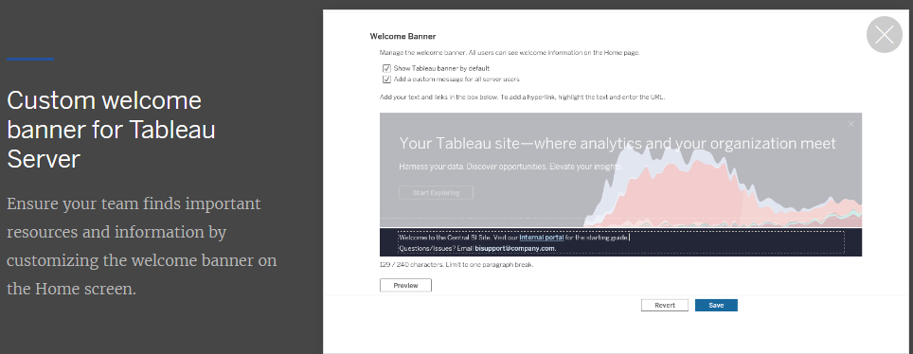

1. **Edit tooltips in the browser:**

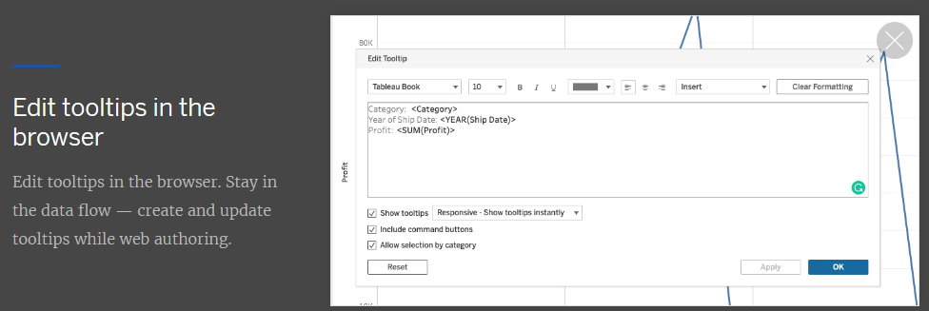

1. **Map improvements in the browser:**

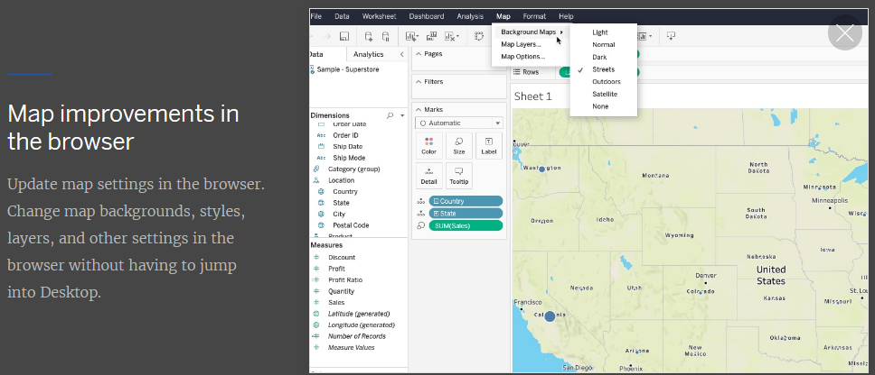

1. **View Recommendation:**

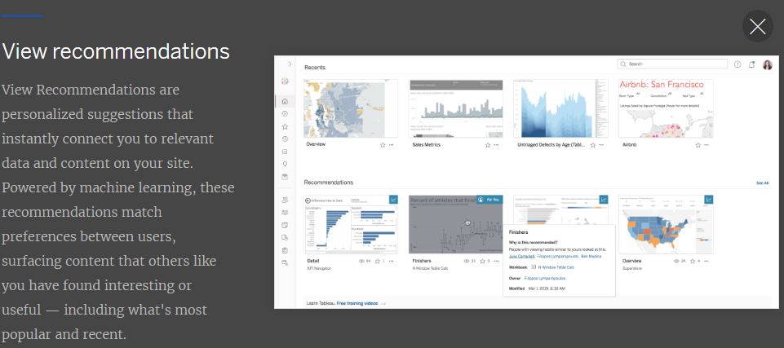

1. **Go to where a sheet is used:**

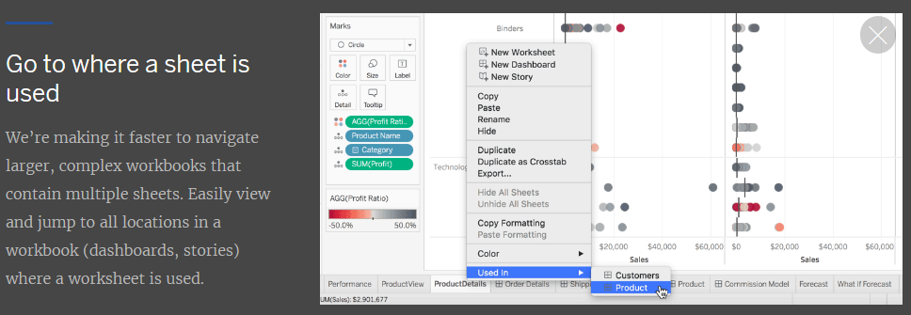

1. **Qubole Connectors:**

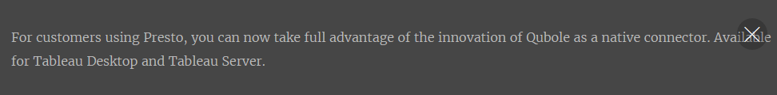

1. **Kyvos Connectors:**

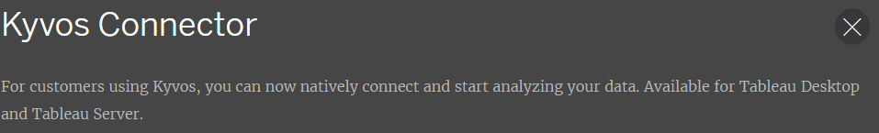

1. **Alibaba Connectors:**

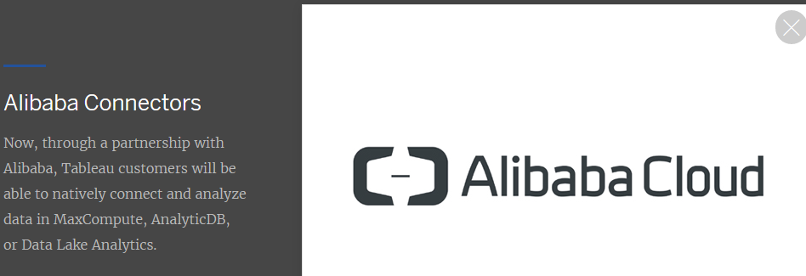

1. **Cloud file connectors for tableau Prep:**

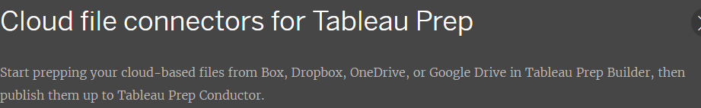

1. **App lock using biometrics:**

